**EDUSOFTHUB**

**A Project Report**

**Submitted by:**

**Dhruv Raj Singh (22MCA30060)**

in partial fulfilment for the award of the degree

of

**Master of Computer Applications**

**Semester 4**

at



**LDRP Institute of Technology and Research**

**MCA Department**

**April 2024**

**CERTIFICATE**

This is to certify that the project titled “**EDUSOFTHUB**” is the bona fide work carried out by **Dhruv Raj Singh**, a student of LDRP Institute of Technology and Research MCA Department, during the academic year 2023-24, in partial fulfilment of the requirements for the award of the degree of MCA Semester 4.

|  |  |
| --- | --- |
| **Internal Guide:** | **Head of Dept. Signature:** |
| **Date:** | **Date:** |

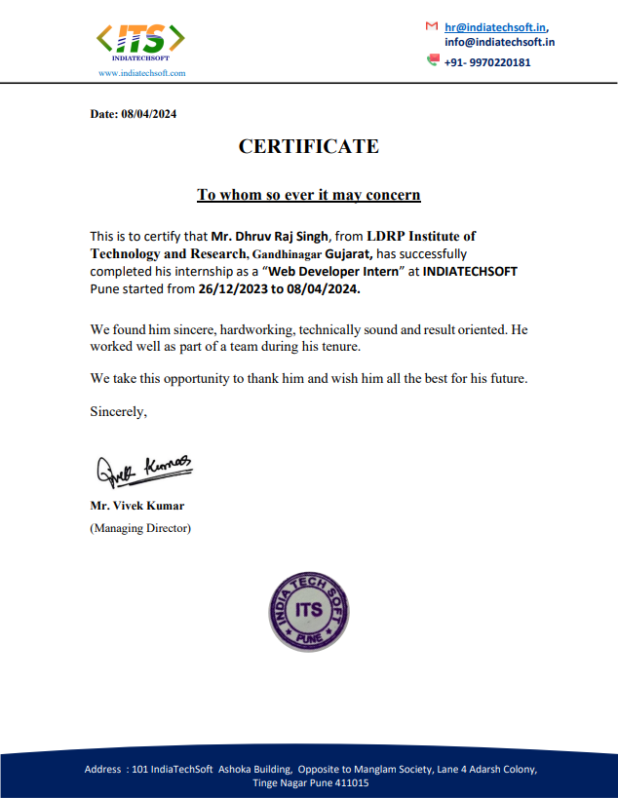

**ACKNOWLEDGEMENT**

The accomplishment of this project would have not been possible individually without the encouragement, assistance and valuable support from various sources.

It is my proud privilege to express my profound gratitude to the entire management of LDRP institute of research and technology and teachers of the institute for providing me with this opportunity to avail the excellent infrastructure.

The knowledge and values gained have provided to be of immense help at the very start of my career. Special thanks to Hon’ble MCA Department Head, Mr. Mahendra Khambhalia for having provided us an excellent infrastructure at LDRP. No creative work is possible in isolation. I need guidance, motivation at every step of my progress.

I would like to add a few heartfelt words for the people who were the part of this project in numerous ways. I am grateful to Mr. Ramesh Chandra Goswami (project guide) for his guidance, constant encouragement and sincere support for this project work.

I extend my heartfelt thanks to for giving me an opportunity to work in such good professional environment and have a good experience. I would like to extend my profound thanks to for providing all the support in the lifetime of the project and their valuable motivation and time to time discussions which kept a constant vigil on the progress of the project

**ABSTRACT**

A school management system serves as a pivotal tool in modern education, revolutionizing administrative processes and fostering a conducive learning environment. By integrating various functionalities such as student enrollment, attendance tracking, academic grading, and resource management, these systems streamline operations, reduce paperwork, and enhance communication among administrators, teachers, students, and parents. With features like online gradebooks, parent portals, and communication modules, they promote transparency and collaboration while empowering educators to focus on teaching. Moreover, school management systems incorporate timetable generation, resource allocation, and financial management, providing administrators with the tools to efficiently organize school schedules and budgets. Through analytics and reporting functionalities, stakeholders can assess performance metrics and make data-driven decisions to improve outcomes. With the integration of mobile applications and online platforms, these systems facilitate seamless communication and access to information, promoting engagement and participation in the educational process. Ultimately, the implementation of a robust school management system is crucial for optimizing administrative operations and nurturing a supportive environment that fosters the holistic development of students.

|  |  |  |
| --- | --- | --- |
| **Sr.No** | **Contents** | **Page No.** |
| 1. | Introduction |  |
|  | 1.1 Project Description | 1 |
|  | 1.2 Company Profile | 2 |
| 2. | Literature Survey |  |
|  | 2.1 Existing System and Proposed System | 3 |
|  | 2.2 Feasibility Study | 5 |
|  | 2.3 Tools and Technologies Used | 7 |
|  | 2.4 Hardware and Software Requirements | 10 |
| 3. | Software Requirement Specification |  |
|  | 3.1 Functional Requirements | 11 |
|  | 3.2 Non- Functional Requirements | 12 |
| 4. | System Design |  |
|  | 4.1 System Perspective | 14 |
|  | 4.2 Context Diagram | 15 |
|  | 4.2.1 Data flow diagram of admin | 17 |

|  |  |  |
| --- | --- | --- |
|  | 4.2.2 Data flow diagram of user | 20 |
| 5 | Detailed Design |  |
|  | 5.1 Use Case Diagrams | 22 |
|  | 5.2 Sequence Diagrams | 23 |
|  | 5.3 Activity Diagrams |  |
|  | 5.3.1 Activity Diagram for admin | 24 |
|  | 5.3.2 Activity Diagram for user | 25 |
|  | 5.4 ER Diagrams | 26 |
| 6 | Implementation |  |
|  | 6.1 Screen Shots | 29 |
| 7 | Software Testing | 44 |
| 8 | Conclusion | 50 |
| 9 | Future Enhancements | 51 |
| 10 | Bibliography | 53 |

**Chapter 1**

Introduction

* 1. **Project Description**

A school management system (SMS) is an information management system designed for educational institutions to manage student data. It is a web and mobile-based application that centralizes data storage, making it easier for administrators, students, teachers, and parents to access data from various devices. SMS can automate various tasks, such as student registration, class documents, grades, and attendance, reducing the workload for administrators, teachers, and staff.

SMS can host modules for maintaining academic histories and student records, and can be used to plan the curriculum, record attendance, and manage student-related needs within the school. It can also be used to facilitate communication between administrators, teachers, parents, and students, and provides a platform for parents to make fee payments and be active participants in their children's education.

There are various school management systems available, with varying sizes, scopes, and abilities. Some are designed for small organizations and cover only student data, while others are enterprise solutions that aim to cover most aspects of the operation of large organizations and their online schools.

**2.2 Company Profile**

**INDIATECHSOFT**



**Website:** **https://indiatechsoft.in**

**Company Size:** 15-20 Employees

**Headquarters:** Pune, Maharashtra

**Specialties:** Training Institute Provide Training for Web Development, Digital Marketing Full stack development, Java, python, Software Testing, Software Development,

**Email address:** [info@indiatechsoft.com](mailto:info@indiatechsoft.com)

**Office address:** 101, IndiaTechSoft , Ashoka Building, Lane No4 , Adarsh Colony, Vishrantwadi Pune-411015

**Chapter 2**

**Literature Survey**

**2.1 Existing and proposed system**

**2.1.1 Existing system**

Manual Processes: In the current system, most administrative tasks such as student registration, attendance tracking, and exam result generation are done manually. This includes filling out paper forms, maintaining physical records, and manually calculating grades.

Limited Accessibility: Information is often stored in physical files or spreadsheets, making it difficult to access and share data among stakeholders. Parents may need to visit the school in person to get updates on their child's progress.

Communication Challenges: Communication between teachers, students, parents, and administrators relies heavily on physical meetings or phone calls. This can lead to delays in sharing important information and updates.

Data Security Risks: Paper records are susceptible to loss, damage, or unauthorized access. There is also a risk of errors in data entry and calculation, leading to inaccuracies in reports and records.

**2.1.2 Proposed system**

Automation: The SMS automates various administrative tasks, reducing the reliance on manual processes. This includes features such as online student registration, automated attendance tracking, and instant result generation.

Centralized Database: All data is stored in a centralized database, making it easy to access, update, and share information in real-time. Teachers, students, parents, and administrators can log in to the system from anywhere, at any time.

Efficient Communication: The SMS includes a messaging system that allows for instant communication between users. Teachers can send notifications about assignments or upcoming events, and parents can receive updates on their child's attendance and academic performance.

Enhanced Security: With secure authentication mechanisms and role-based access control, the SMS ensures data security and privacy. Encrypted data transmission and secure storage protect sensitive information from unauthorized access.

User-Friendly Interface: The SMS features a user-friendly interface that is easy to navigate for all users. This includes clear dashboards, intuitive menus, and customizable options based on user roles.

**2.2 Feasibility Study**

This study is an appraisal of reasonableness of a developed task or framework. It takes task's examine factor that incorporates monetary, specialized, lawful and plan that consider the venture ought to be finished effectively, It is where the undertaking is planned that endorses whether this task is conceivable or not.

**The goals of feasibility study are as follows:**

* To look at whether the web application will meet organizations prerequisites.
* To review if the web application should be possible with available innovation inside specific financial plan and calendar.

**Variations of feasibility study:**

* Technical
* Legal operational
* Economic
* Schedule

**Technical feasibility**: it talks about what are all the technologies which should be used for the project. Basically, it deals the technologies which are required to develop the project.

**Legal feasibility**: it is a check done to check whether all the legal requirements are ensured by the project so that there will be no further legal complications.

**Operational feasibility**: It decides the exhibition of the system whether the software can play out the necessary activity and ready to tackle the intricacies and whether it fulfills the prerequisites which is given from the company while collecting the requirements.

**Economic feasibility**: it endorses the expense for activity i.e., to investigate whether the venture is finished within assessed budget. Greater part of the undertakings is done inside the spending plan with the use of open- source technologies which is accessible in the industry.

**Schedule feasibility**: it is an assessment of the project, whether will it be finished under the specified time or will it take more duration than the specified time.

**2.3 Tools and Technology used**

**2.3.1 Technology are used for developing the application are as follows:**

**Front End:**

* Html
* Bootstrap
* Cascading style sheet

**Back End**

* PHP

**Database**

* MySQL

#### HTML:

Hypertext Markup language is the foundation for creating any sort of web pages and web applications. When HTML is used along with the combination of CSS along with JavaScript, it will create a wonder in World Wide Web.

It is basic but still powerful language which gives ability to any developer or newbies to the html platform to the html platform to develop a static webpage with little effort. If the creators have minimum knowledge of html structure and knows how it works can easily create a web page without putting much effort.

#### CASCADING STYLE SHEET:

It is assumed to be a significant job in transforming the site to look increasingly brilliant, appealing where it incorporates the different kinds of shading codes, text dimensions, textual style and so forth the pages created utilizing the outside sheets helps in stacking the pages quicker. The application developed is responsive in nature and perfect with different programs accessible.

CSS is for the most part utilized for styling reason where after the page is been structured it is utilized to give the beautiful completion to the pages in turn it transforms the page to look more brilliant and increasingly appealing.

#### Bootstrap:

Bootstrap is one of the noticeable front-end technologies used in present days. It is easy, normal, and astounding front-end framework for quicker and easier web development process. It includes HTML, CSS. The last items a similar for composing, tables and structural segments transversely over web programs.

Bootstrap also has JavaScript code included in it. They provide additional UI parts, for model, talk boxes. Every Bootstrap fragment involves a HTML structure, CSS certifications as well as JavaScript code.

#### 

#### PHP:

PHP is one of the, XHTML installed documenting language used from server space and it acts like a substitute to many other technologies.

PHP is a documenting language used from the server space, it is normally utilized for structure dealing with and database gets to. It is an absolutely deciphered and utilizes dynamic composing; PHP has broad collections of capacities making it an adaptable and integral asset for server-side programming advancement.

A significant number of the predefined capacities are utilized to give interfaces to other programming frameworks, for example, mail and database framework.

#### MYSQL:

MySQL is considered to be one of the secure and dependable databases which are utilized in the vast majority of the application engineers. In this application as insert to the data and treatment of the inserted data of the representatives in an excel expectations the information is being put away in the database which makes the client in simple treatment of the information and can likewise follow the information of the workers and the information won't be traded if there are multiple workers with a similar name.

Database diminishes the confusion in including and expelling of data which is accumulated in the databases.

**2.4 Hardware and software requirement**

**Hardware Requirements**

CPU : Pentium - III

Hard Disk : 500GB

RAM : 4GB RAM

Graphics Card : 2GB

**Software Requirements**

Operating System : Window 7/8/10

Editor : Sublime text 3

Server : Xampp SERVER

Front End : Cascading Style Sheet (CSS), HTML

Database : MySQL

Back End : PHP

**Chapter 3**

**Software Requirements Specification**

* 1. **Functional Requirements**

The usefulness of the framework is being characterized by the functional requirements. It relies upon the kind of programming utilized and the clients who utilize the application. This characterizes which are main and essential administrations or functionalities which are conveyed in the system.

* + 1. **Login Page**

First farmers have to register to the application before start using it. In log in page user has to give his personal credentials so that he can successfully register to the application. Using the information given during registration process users can get accessed to the application. If the user provides wrong credentials or incorrect data while logging into the page, he wan’t able to access into system.

* + 1. **Main Screen**

It is a page which gives full information to the user of what the application is all about and what it can do. Here the users can choose whatever they wanted to do with the application. Home page is self-explanatory and users can easily go with the flow of the application. This is place where clients can edit them information which was given to the application.

* + 1. **Modify**

In this page clients can modify the data which he has given to the application. He has all the privilege to update and edit his personal details.

* + 1. **Logout**

After performing all tasks or activities client can come out of the application by using this page.

If the farmers feel he should come out of the application at any point in time he does that with this page.

* 1. **Non-functional Requirements**

It is a kind of requirement which judges the overall success of any application. These are the sort of prerequisites where the vital necessities can be roughly met while building up the application. It determines and characterizes how the framework functions after it has been created.

* + 1. **Performance**

It relies on how quick the application functions when there are numerous clients who are getting in to the application. It might incorporate the transferring of documents, opening various pages at a solitary time. How quick the information is being handled when the application is being utilized by multiple users at the same time.

* + 1. **Dependability**

It characterizes how the system which is created is solid to be utilized by the clients.

It for the most part characterizes how and in which sort of conditions the product neglects to work or takes greater time to respond to the user actions. When huge number of different clients utilizing the system at a solitary time the server may get occupied and the handling of information of the clients can turn out to be moderate or may even stop now and then for a significant stretch of time.

* + 1. **Maintainability**

The system can be utilized by different clients one after another. The framework is created in such a way so that any module, sub module is included, refreshed, altered or erased won't influence the remainder of different modules which are currently in working state.

* + 1. **Flexibility**

Each time there will be a gathering of individuals who put in their endeavors to make a software to work effectively. The software can be created in different stages and can likewise be refreshed to the most recent innovations and the forms accessible.

**Chapter 4**

**System Design**

**4.1 System Prospective**

Enhancement of coding process habitually needs strong interfaces with expand the administrators and control works out, which are stressed over perceiving the need of method change and actuating improving exercises. Undertaking the officials, on the other hand, normally misses the mark at picking appropriate programming structuring systems and advancement that help to ensure adventure accomplishment.

It depicts a model that aides project chiefs

* To establish an assignment with the objective that it can accomplish its specific goals.
* To distinguish helpful changes once an endeavor is threat of failing its destinations.

The probability of an application viewpoint is to utilize a non-reduced way to deal the errand of depicting the properties of the framework itself. In the system point of view, when individual perceived the framework as a substitute piece of the world one doesn’t permit to steadily isolate the structure into separated parts. Or then again might be one is made plans to delineate the structure with everything taken into account. In the event that one uses section into parts, as a portion of the outline of the application behavior that is basically bit of a flat-out delineation of the lead of the total.

It could be expressed as the initial step of recognizing the arrangement from the beginning of the issue, the primary point of developing the software is to identify and upgrade the prerequisite of a framework into code.

**4.2 Data-flow Diagram**

It is also referred as Context diagram. This diagram decides limit of the framework or parts of the framework and its condition, showing the elements that communicate with it. Setting Diagram is the elevated level perspective on the framework; it is a typical device that Business Analysts use to comprehend.

It depicts the outline behavior needed by the outer elements; it very well may be disintegrated into various levels in progressive way.

#### DATA FLOW DIAGRAM NOTATIONS

Data flow

Process

File or Database

Input or Output

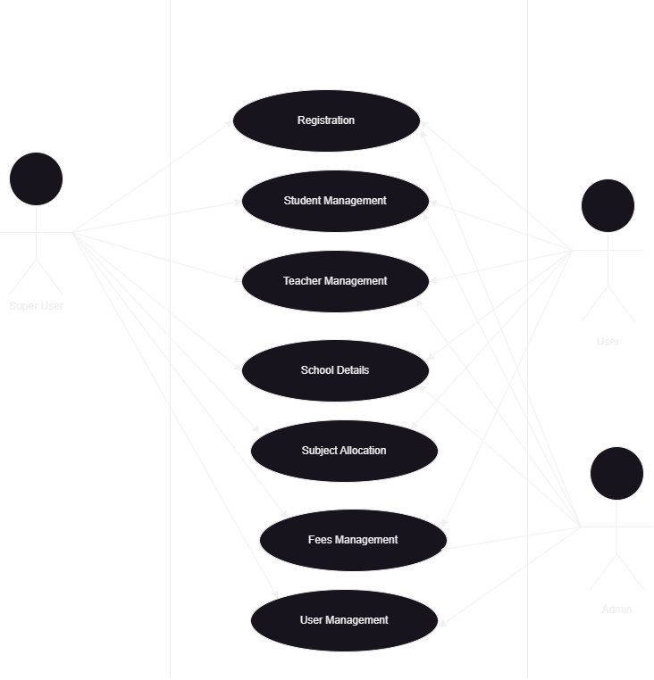

Above diagram tries to explain data flow in project from the admin perspective. Here admin login to the application using valid credentials, here the admin can access management, Manage student, manage teacher, manage fees and he can view user login log.

Data Flow Diagram

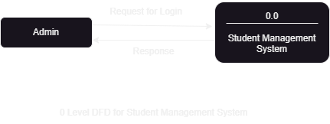

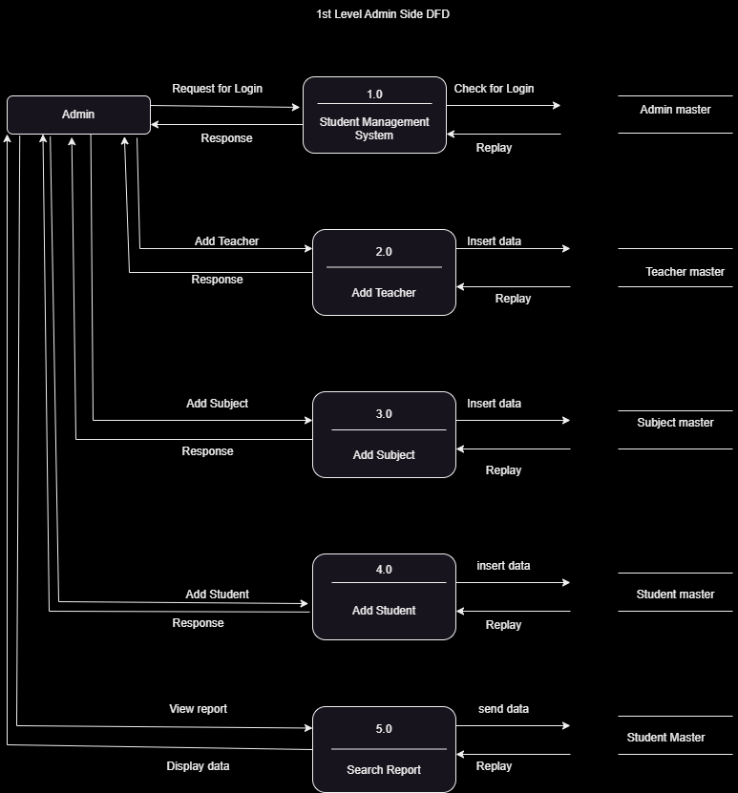

1st Level – Admin Side Data Flow Diagram

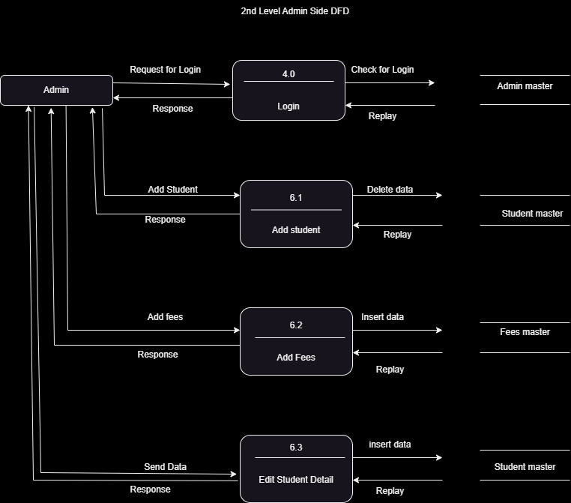

2nd Level – Admin Side Data Flow Diagram

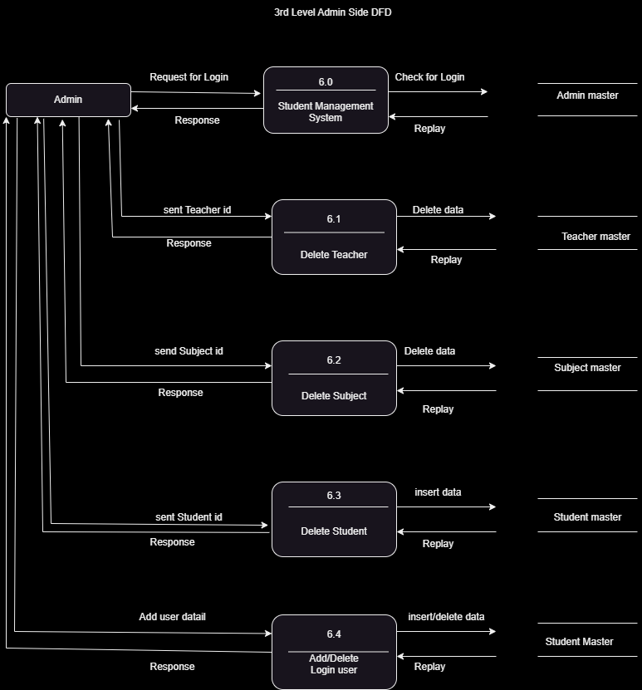

3rd Level – Admin Side Data Flow Diagram

**Chapter 5**

**Detailed Design**

* 1. **Use Case Diagram**

It expresses the working and the connection between the client and the application; It displays the usefulness of the framework utilizing entertainers and use cases. The main motivation behind a use case outline is to show what system capacities are performed by the entertainer. Jobs of the on-screen entities in the application could be depicted.

Use case is the assortment of activities, capacities that should be played out, these are otherwise called conduct chart that depicts the conduct of the application.

**Use Case Diagram Notations**

System

Use case

Association

Actor



Figure 5.1.1 helps to easily understand the flow in the project. It shows which modules which admin and user can are able to access in application.

* 1. **Sequence Diagram**

Sequence diagrams are otherwise called event diagrams, that depicts the connection among items and it portrays the framework working request and it centers on the message trade between the helps.

Figure 5.2.1 will help to understand the sequence in which the control flows in the system. Here admin and user log in to the application with valid credentials, system verifies it with database it it is correct they will get access to the application. Likewise, how every operation is performed in the system is depicted in the figure. It has four main things that are admin, user, system, and database.

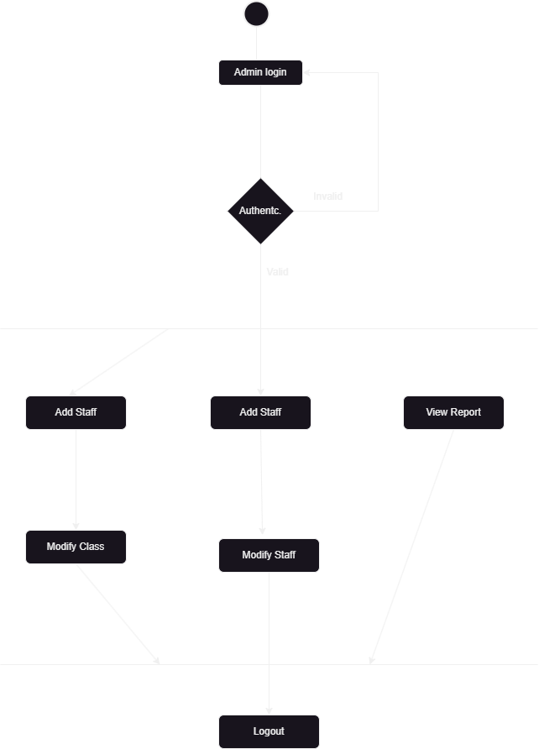

**Admin Activity Diagram**

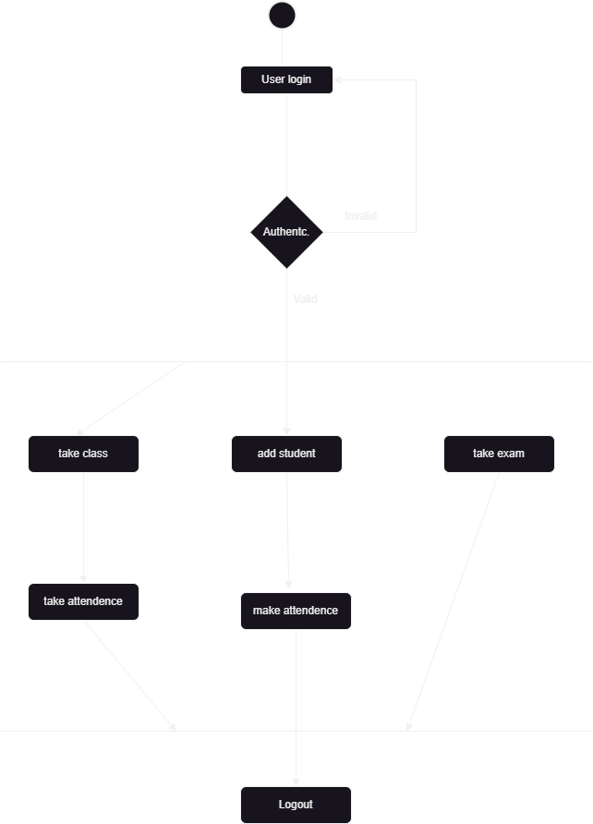

**User Activity Diagram**

* 1. **Entity Relationship [E-R] Diagram**

This Diagram characterizes the E-R model that depicts the format of the database. It depicts the one substances of connection and one examples.

This is addressed by techniques for an ER plot. For example, substances, attributes of a component, relationship, and qualities of relationship sets, can be addressed with the help of an ER plot.

E-R DIAGRAM NOTATION

Attribute

Entity

Relationship

It links Attributes and entity

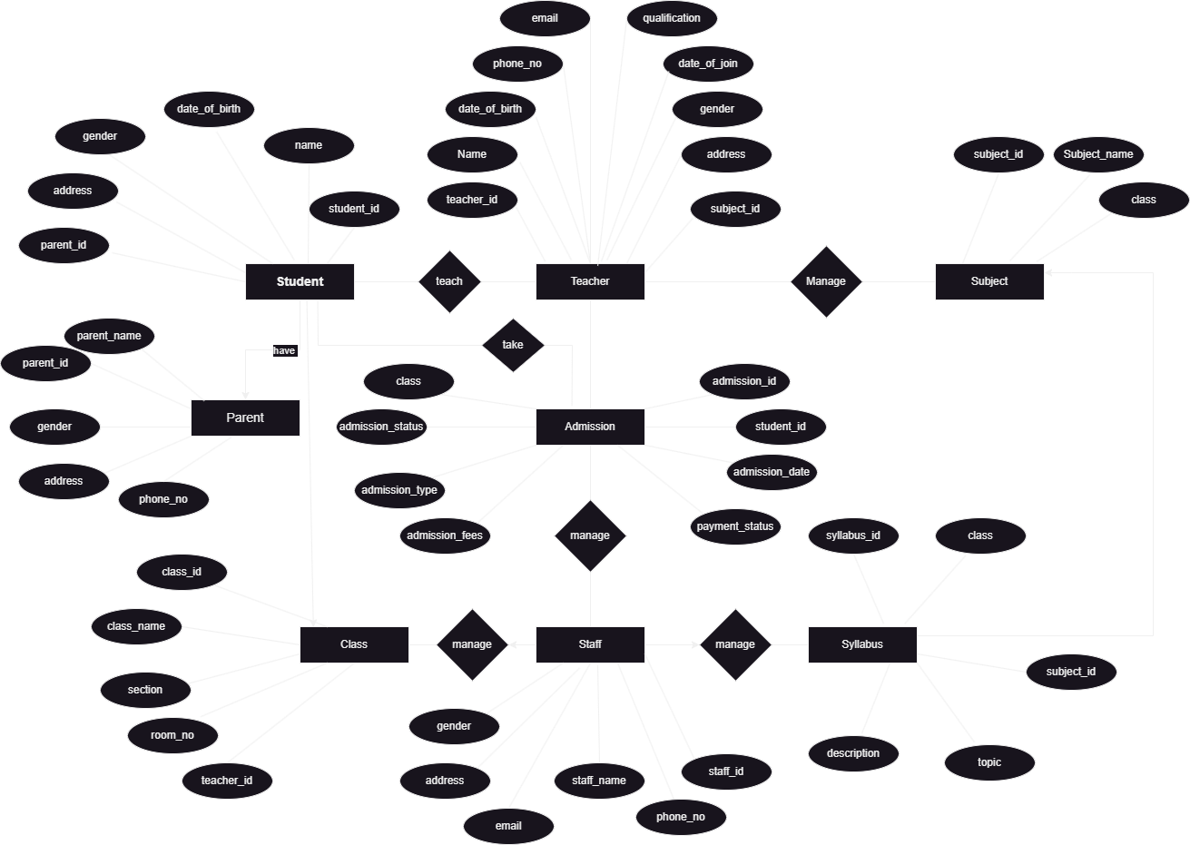

Figure 5.4.1 is depicting the entities in the system and its attribute and also the relationship among the entities. Here there are few major entities Student, Teachers, Staff, Admission, Class, Syllabus, Subject, Parents. These are the few entities around which the system is built. This diagram will help to understand how the entities are related to each other just by looking into the figure. It reduces the effort of the end user or developer which is invested in understanding the flow in the application by reading the lengthy documents, which is time consuming as well difficult. Always figures will give more clarity about the application flow when compared to the reading software documents. It is giving a precise idea of entities and its attributes.

**Chapter 6**

**Implementation**

Usage is where venture practitioner makes arrangement as according to his perspective to make it genuine and to get appropriate result. Arranging is a fundamental piece of any productive endeavor. To finish a venture the execution plan that shocks the errand is basic.

Implementation is the route toward format of the application as demonstrated by its arrangement. Developer makes use of html code to design the web pages. By Html is one of the simplest and wisely used technologies by all front-end developers

The utilization methodology takes subsequent to coding part; however, it incorporates using a particular accentuation for developing the web formats. In spite of the way that there are robotized gadgets to facilitate with the advancement of documents, a serious building up in upgrades the web expert's capacity.

**6.1 Screenshots**

**Table Design**

**6.1.1 Admin**

| **Field Name** | **Data Type** | **Description** |
| --- | --- | --- |
| admin_id | INT | Primary key, auto-generated |
| username | VARCHAR(50) | Unique username for admin login |
| password | VARCHAR(100) | Encrypted password for admin login |
| Designation | VARCHAR(100) | Designation of the admin |
| email | VARCHAR(100) | Email address of the admin |
| phone_number | VARCHAR(20) | Phone number of the admin |

Figure 6.1.1 contains the name which is used while creating the admin table

* **admin_id**: This is a unique identifier for each admin in the system. It serves as the primary key and is auto-generated by the database.
* **username**: Admins will use this username to log in to the system. It should be unique to each admin to ensure proper identification.
* **password**: The admin's password is stored in an encrypted format (hashed) to enhance security. Only the hashed version is stored in the database.
* **full_name**: This field stores the full name of the admin for display and identification purposes.
* **email**: The email address of the admin is stored here. It allows for communication with the admin and can be used for password recovery or notifications.
* **phone_number**: This field stores the phone number of the admin, which can be used for contact purposes.

**6.1.2 Student**

| **Field Name** | **Data Type** | **Description** |
| --- | --- | --- |
| student_id | INT | Primary key, auto-generated |
| first_name | VARCHAR(50) | First name of the student |
| last_name | VARCHAR(50) | Last name of the student |
| date_of_birth | DATE | Date of birth of the student |
| gender | ENUM('Male', 'Female', 'Other') | Gender of the student |
| address | VARCHAR(255) | Address of the student |
| email | VARCHAR(100) | Email address of the student |
| phone_number | VARCHAR(20) | Phone number of the student |

Figure 6.1.2 contains the name which is used while creating the student table.

* **first_name**: Stores the first name of the student.
* **last_name**: Stores the last name of the student.
* **date_of_birth**: Stores the date of birth of the student.
* **gender**: Enumerated field for the student's gender, with options 'Male', 'Female', or 'Other'.
* **address**: The address of the student's residence.
* **email**: The email address of the student, used for communication and login purposes.
* **phone_number**: Stores the phone number of the student.

**6.1.3 Teacher**

| **Field Name** | **Data Type** | **Description** |
| --- | --- | --- |
| teacher_id | INT | Primary key, auto-generated |
| first_name | VARCHAR(50) | First name of the teacher |
| last_name | VARCHAR(50) | Last name of the teacher |
| email | VARCHAR(100) | Email address of the teacher |
| phone_number | VARCHAR(20) | Phone number of the teacher |
| address | VARCHAR(255) | Address of the teacher |
| date_of_birth | DATE | Date of birth of the teacher |
| gender | ENUM('Male', 'Female', 'Other') | Gender of the teacher |
| qualification | VARCHAR(100) | Qualification or degree of the teacher |
| join_date | DATE | Date when the teacher joined the school |
| subject_taught | VARCHAR(100) | Subject(s) taught by the teacher |
| class_teacher | BOOLEAN | Flag indicating if the teacher is a class teacher |

Figure 6.1.3 contains the name which is used while creating the teacher table

* **teacher_id**: This is a unique identifier for each teacher in the system. It serves as the primary key and is auto-generated by the database.
* **first_name**: Stores the first name of the teacher.
* **last_name**: Stores the last name of the teacher.
* **email**: The email address of the teacher, used for communication and login purposes.
* **phone_number**: Stores the phone number of the teacher, used for contact purposes.
* **address**: The address of the teacher's residence or work location.
* **date_of_birth**: Stores the date of birth of the teacher.
* **gender**: Enumerated field for the teacher's gender, with options 'Male', 'Female', or 'Other'.
* **qualification**: Stores the qualification or degree held by the teacher.
* **join_date**: Date when the teacher joined the school.
* **subject_taught**: Stores the subject(s) taught by the teacher.
* **class_teacher**: Boolean field indicating whether the teacher is a class teacher or not.

**6.1.4 Parents**

| **Field Name** | **Data Type** | **Description** |
| --- | --- | --- |
| parent_id | INT | Primary key, auto-generated |
| parent_name | VARCHAR(100) | Full name of the parent or guardian |
| email | VARCHAR(100) | Email address of the parent or guardian |
| phone_number | VARCHAR(20) | Phone number of the parent or guardian |
| address | VARCHAR(255) | Address of the parent or guardian |
| student_id | INT | Foreign key referencing the student the parent is associated with |

Figure 6.1. contains the name which is used while creating the parent table

* **parent_id**: This is a unique identifier for each parent in the system. It serves as the primary key and is auto-generated by the database.
* **parent_name**: Stores the full name of the parent or guardian.
* **email**: The email address of the parent or guardian, used for communication and notifications.
* **phone_number**: Stores the phone number of the parent or guardian.
* **address**: The address of the parent or guardian.
* **student_id**: Foreign key referencing the student the parent is associated with. This establishes a relationship between the parent and the student(s) they are responsible for.

**6.1.5 Staff**

| **Field Name** | **Data Type** | **Description** |
| --- | --- | --- |
| staff_id | INT | Primary key, auto-generated |
| staff_name | VARCHAR(100) | Full name of the staff member |
| email | VARCHAR(100) | Email address of the staff member |
| phone_number | VARCHAR(20) | Phone number of the staff member |
| address | VARCHAR(255) | Address of the staff member |
| date_of_birth | DATE | Date of birth of the staff member |
| gender | ENUM('Male', 'Female', 'Other') | Gender of the staff member |

Figure 6.1.5 contains the name which is used while creating the staff table

* **staff_id**: This is a unique identifier for each staff member in the system. It serves as the primary key and is auto-generated by the database.
* **staff_name**: Stores the full name of the staff member.
* **email**: The email address of the staff member, used for communication and notifications.
* **phone_number**: Stores the phone number of the staff member.
* **address**: The address of the staff member.
* **date_of_birth**: Stores the date of birth of the staff member.
* **gender**: Enumerated field for the staff member's gender, with options 'Male', 'Female', or 'Other'.

**6.1.6 Subject Table**

| **Field Name** | **Data Type** | **Description** |
| --- | --- | --- |
| subject_id | INT | Primary key, auto-generated |
| subject_name | VARCHAR(50) | Name of the subject |
| class | VARCHAR(20) | Class or grade associated with the subject |

Figure 6.1.6 contains the name which is used while creating the subject table

* **subject_id**: This is a unique identifier for each subject in the system. It serves as the primary key and is auto-generated by the database.
* **subject_name**: Name of the subject, such as "Mathematics," "Science," "English," etc.
* **class**: Class or grade associated with the subject. For example, "Class 10," "Grade 5," etc. This field links the subject to the specific class it is taught in.

**6.1.7 Syllabus**

| **Field Name** | **Data Type** | **Description** |
| --- | --- | --- |
| syllabus_id | INT | Primary key, auto-generated |
| class | VARCHAR(20) | Class or grade the syllabus is for |
| subject_id | INT | Foreign key referencing the subject |
| topics | TEXT | Detailed list of topics in the syllabus |
| description | TEXT | Description or overview of the syllabus |

Figure 6.1.7 is a table of users with their personal details like name, email, and contact number.

**6.1.8 Admission**

| **Field Name** | **Data Type** | **Description** |
| --- | --- | --- |
| admission_id | INT | Primary key, auto-generated |
| student_id | INT | Foreign key referencing the student being admitted |
| admission_date | DATE | Date when the admission took place |
| admission_type | VARCHAR(50) | Type of admission (e.g., New Admission, Transfer) |
| admission_status | VARCHAR(50) | Admission status (e.g., Pending, Approved, Rejected) |
| enrolled_class | VARCHAR(50) | Class in which the student is admitted |
| admission_fee | DECIMAL(10, 2) | Admission fee amount |
| payment_status | VARCHAR(50) | Payment status of the admission fee |

Figure 6.1.8 contains the name which is used while creating the subject table

* **admission_id**: This is a unique identifier for each admission record in the system. It serves as the primary key and is auto-generated by the database.
* **student_id**: Foreign key referencing the student being admitted. This establishes a relationship between the admission record and the student.
* **admission_date**: Date when the student was admitted to the school.
* **admission_type**: Indicates the type of admission, such as 'Regular', 'Transfer', 'Special', etc.
* **admission_status**: Enumerated field indicating the status of the admission. Options include 'Pending', 'Approved', or 'Rejected'.
* **enrolled_class**: Stores the class the student is enrolled in after admission.
* **admission_fees**: Stores the admission fees paid by the student, if applicable. The data type **DECIMAL(10, 2)** allows for a fixed-point number with 10 digits, 2 of which are decimals.
* **payment_status**: Enumerated field indicating the payment status of the admission fees. Options include 'Paid' or 'Pending'.

**6.1.9 Class**

| **Field Name** | **Data Type** | **Description** |
| --- | --- | --- |
| class_id | INT | Primary key, auto-generated |
| class_name | VARCHAR(20) | Name or identifier for the class |
| section | VARCHAR(10) | Section of the class (optional) |
| teacher_id | INT | Foreign key referencing the teacher assigned to the class |
| room_number | VARCHAR(10) | Room number or identifier for the class |

6.1.9 contains the name which is used while creating the subject table

* **class_id: This is a unique identifier for each class in the system. It serves as the primary key and is auto-generated by the database.**
* **class_name: Name or identifier for the class, such as "Class 10", "Grade 5", etc.**
* **section: Section of the class, if applicable. For example, "A", "B", "C" for Class 10A, Class 10B, etc.**
* **teacher_id: Foreign key referencing the Teacher table. This links the class to the teacher assigned to it.**
* **room_number: Room number or identifier for the class's physical location.**

**Screenshots**

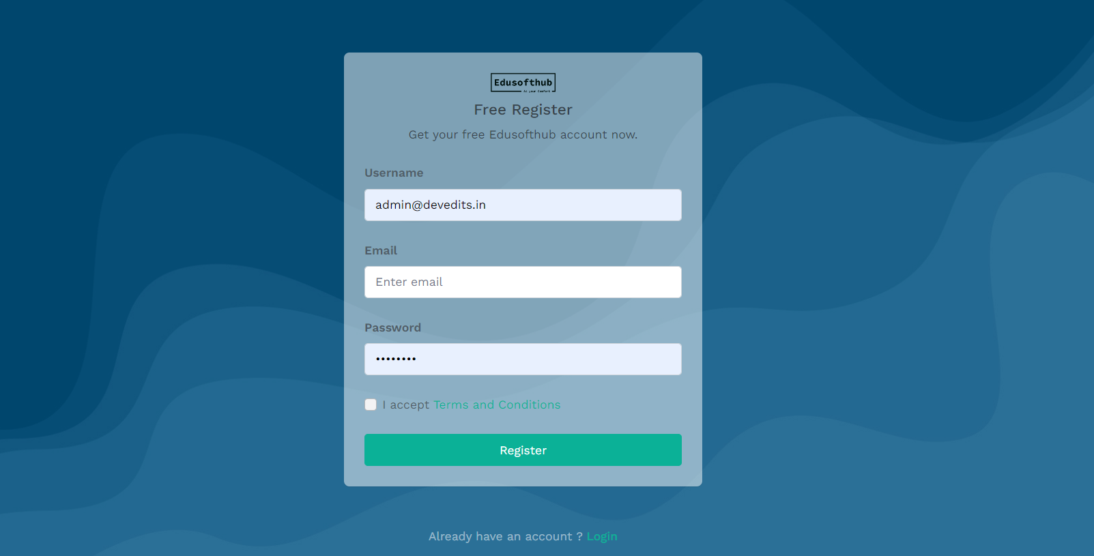

**6.1.10 User Registration or Sign-up page**

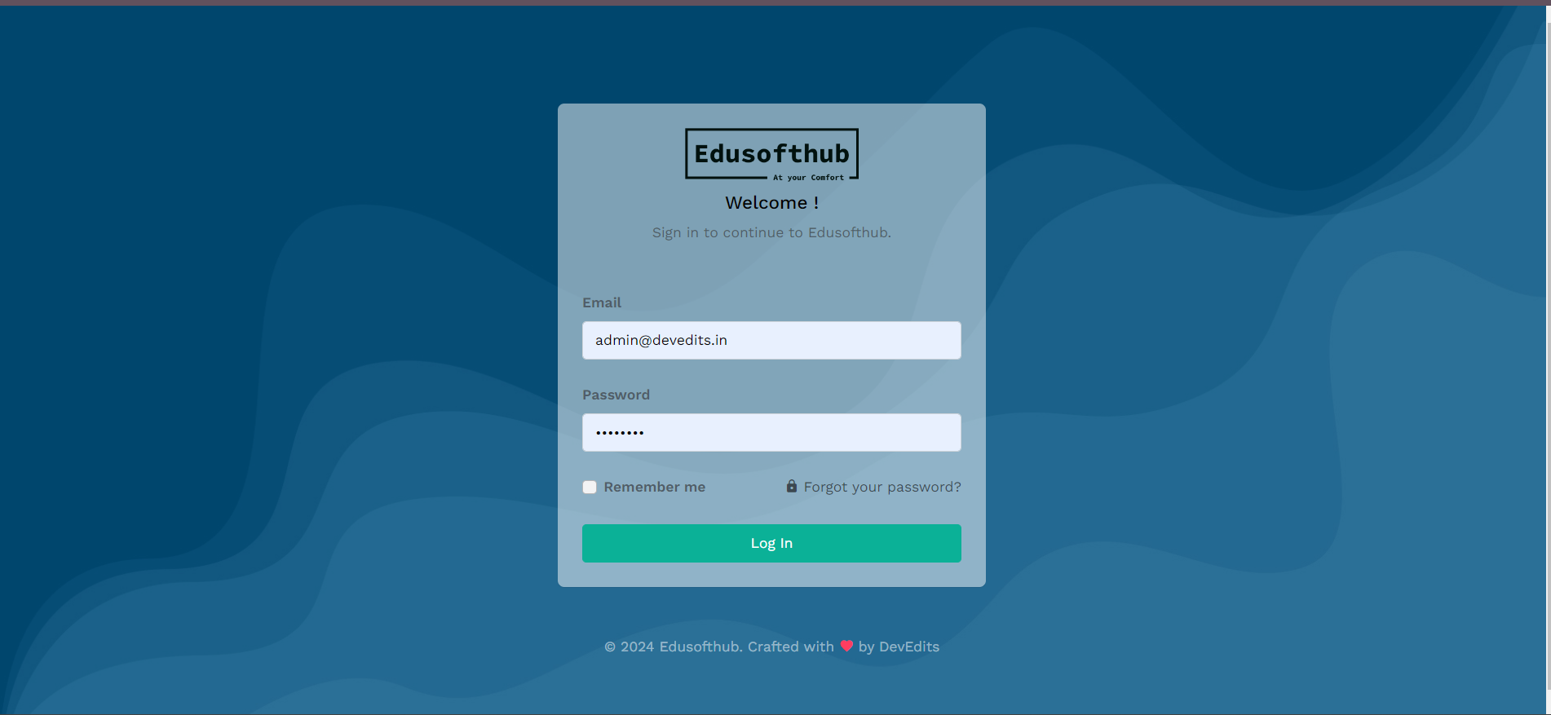

**6.1.11 Login Page**

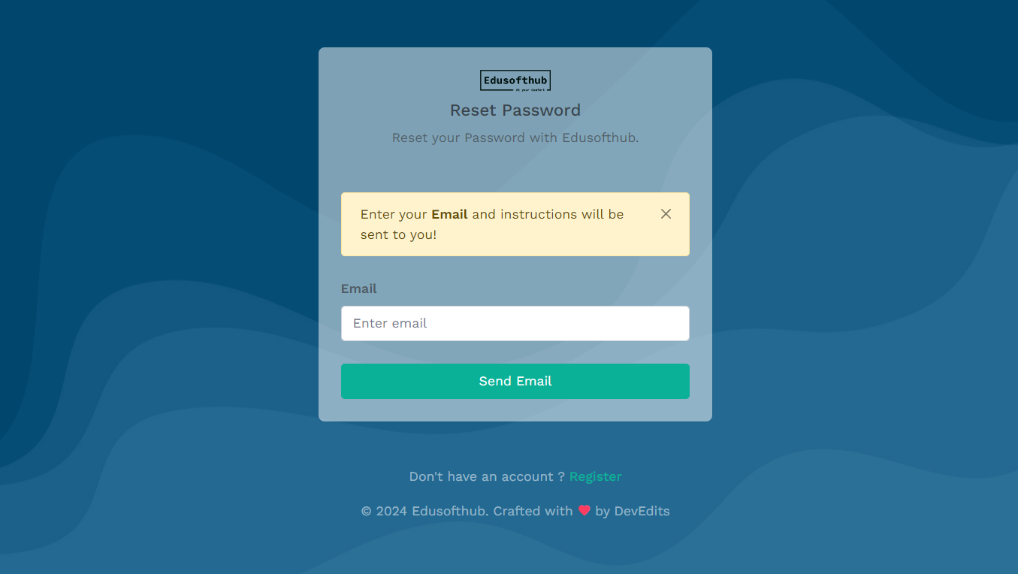

**6.1.12 Forgot Password**

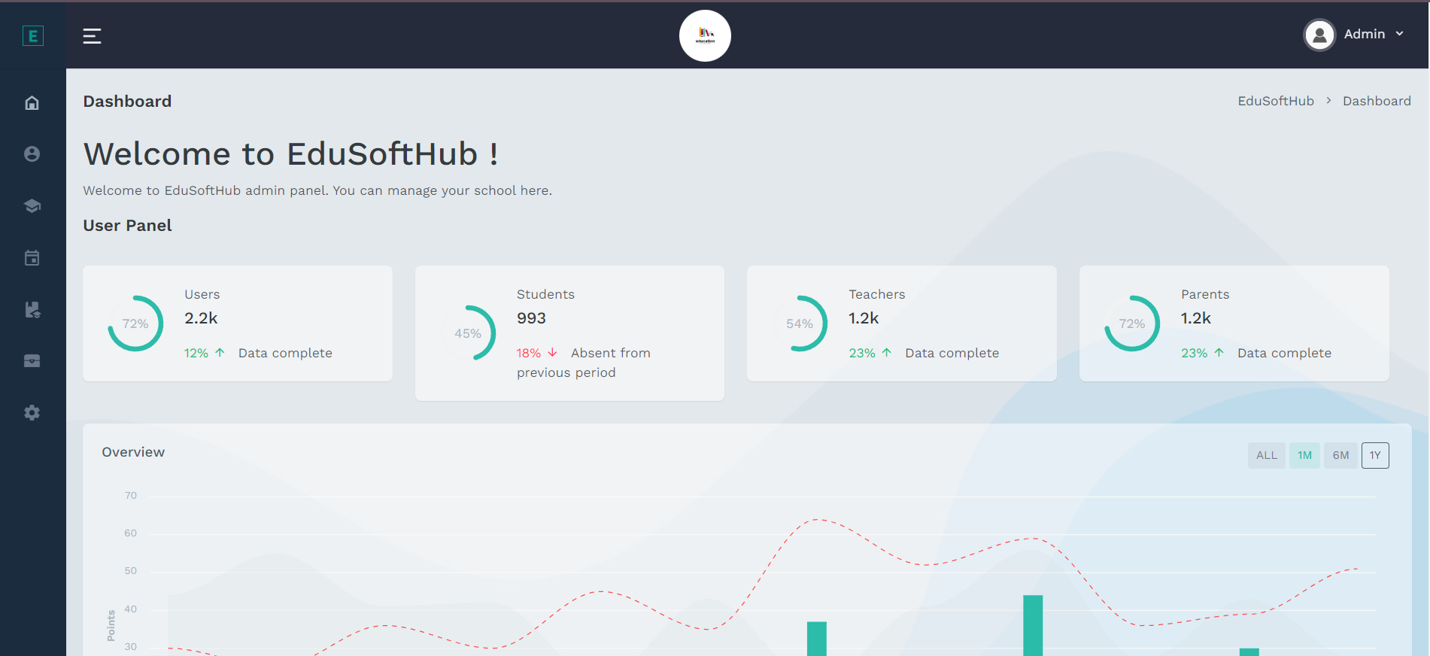

**6.1.13 Home Screen of EduSoftHub**

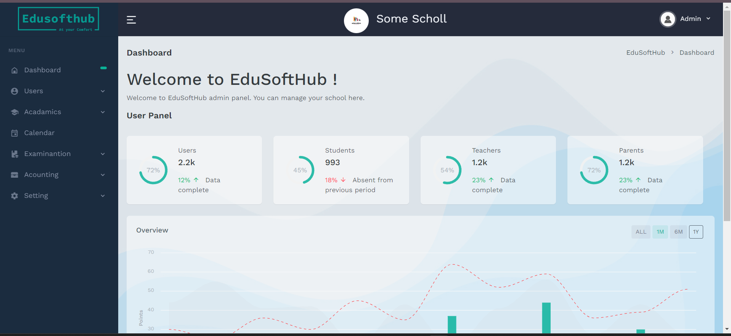

**6.1.14 Dashboard**

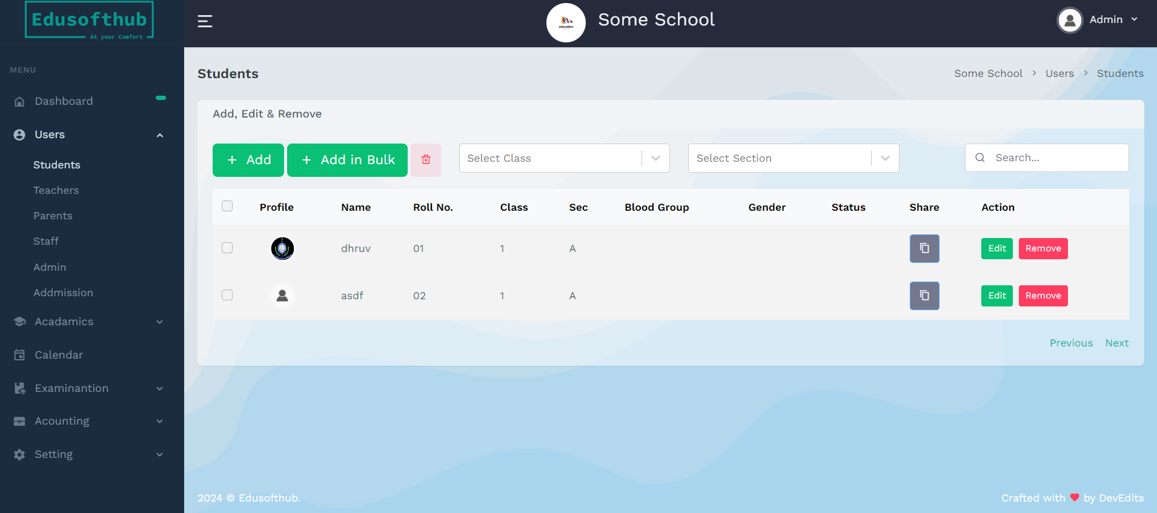

**6.1.15 Selected fashion item with details**

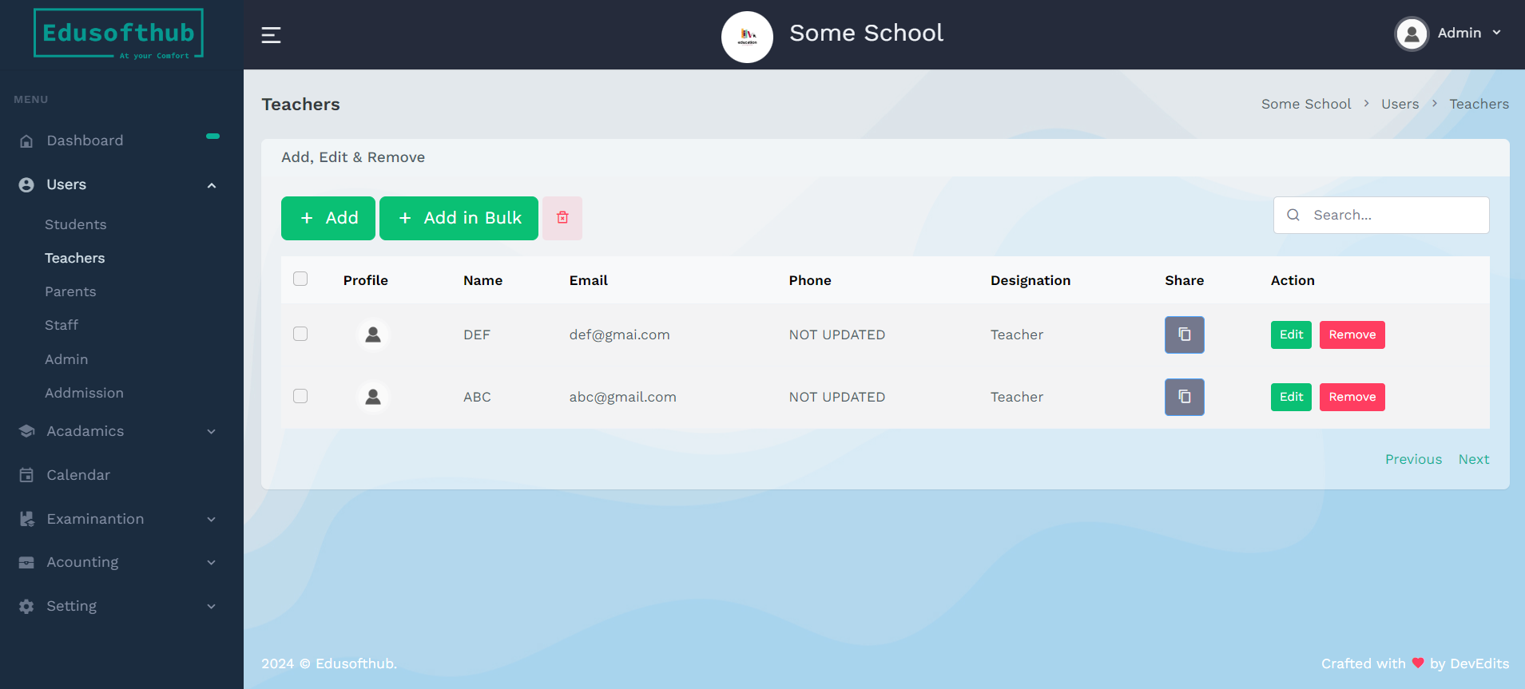

**6.1.16 Admin can add , remove and edit teacher from here**

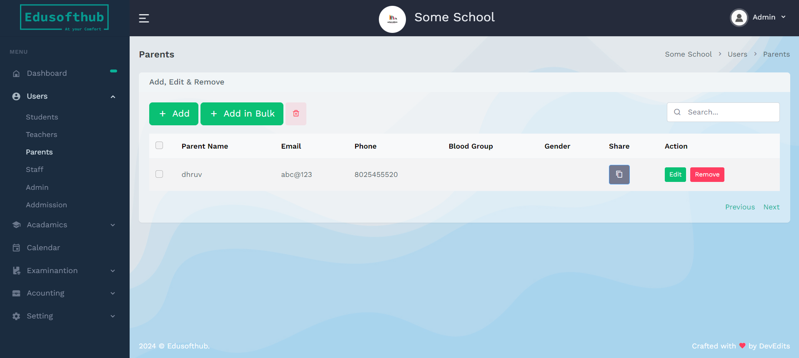

**6.1.17 Admin can add , remove and edit Parent from here**

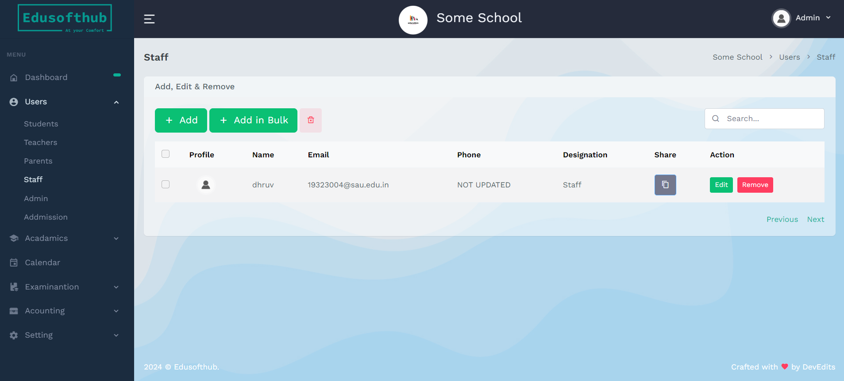

**6.1.18 Admin can add , remove and edit Staff from here**

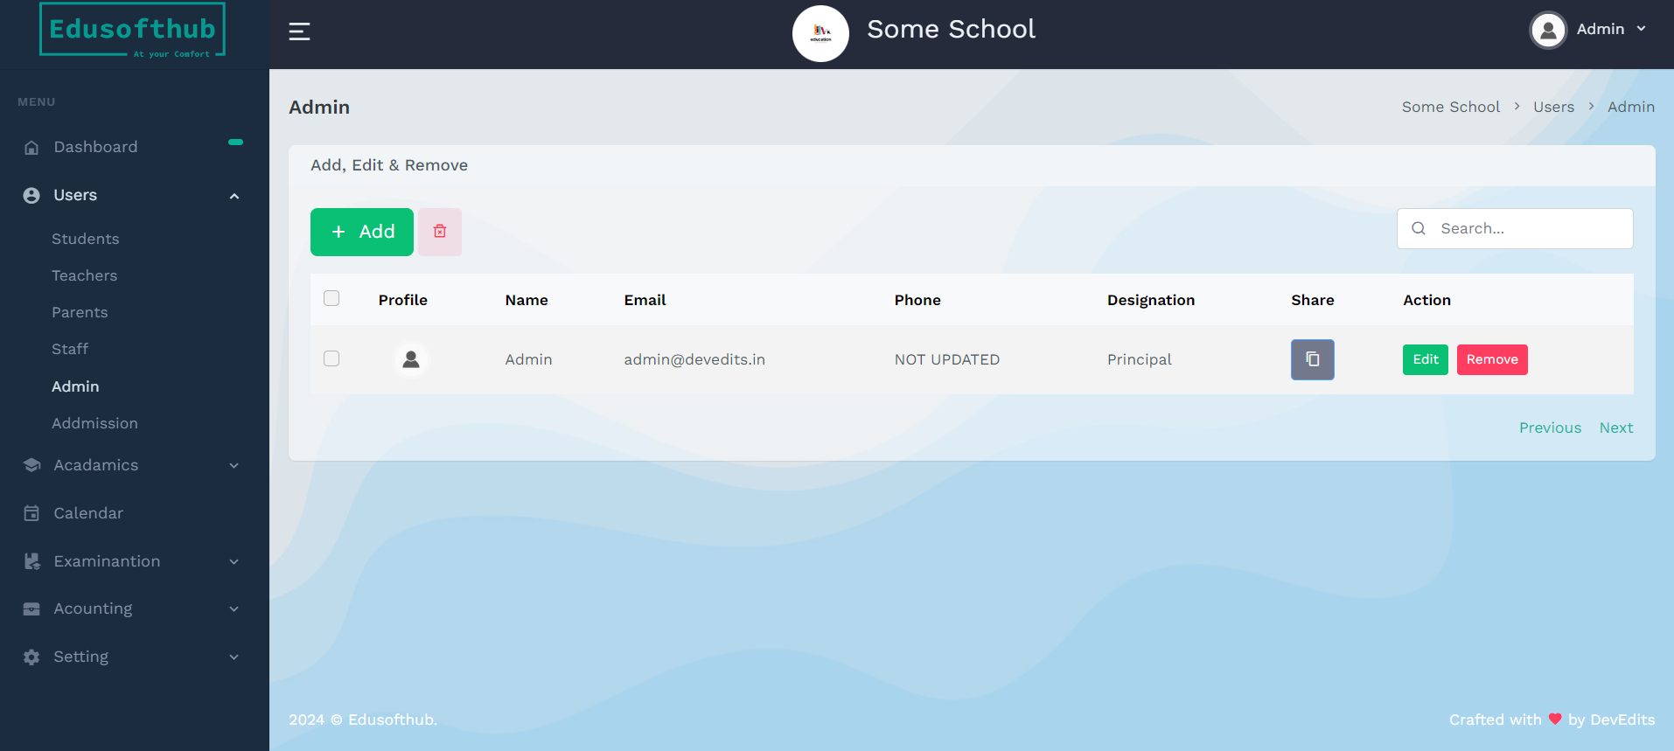

**6.1.19 This is our Admin Pannel**

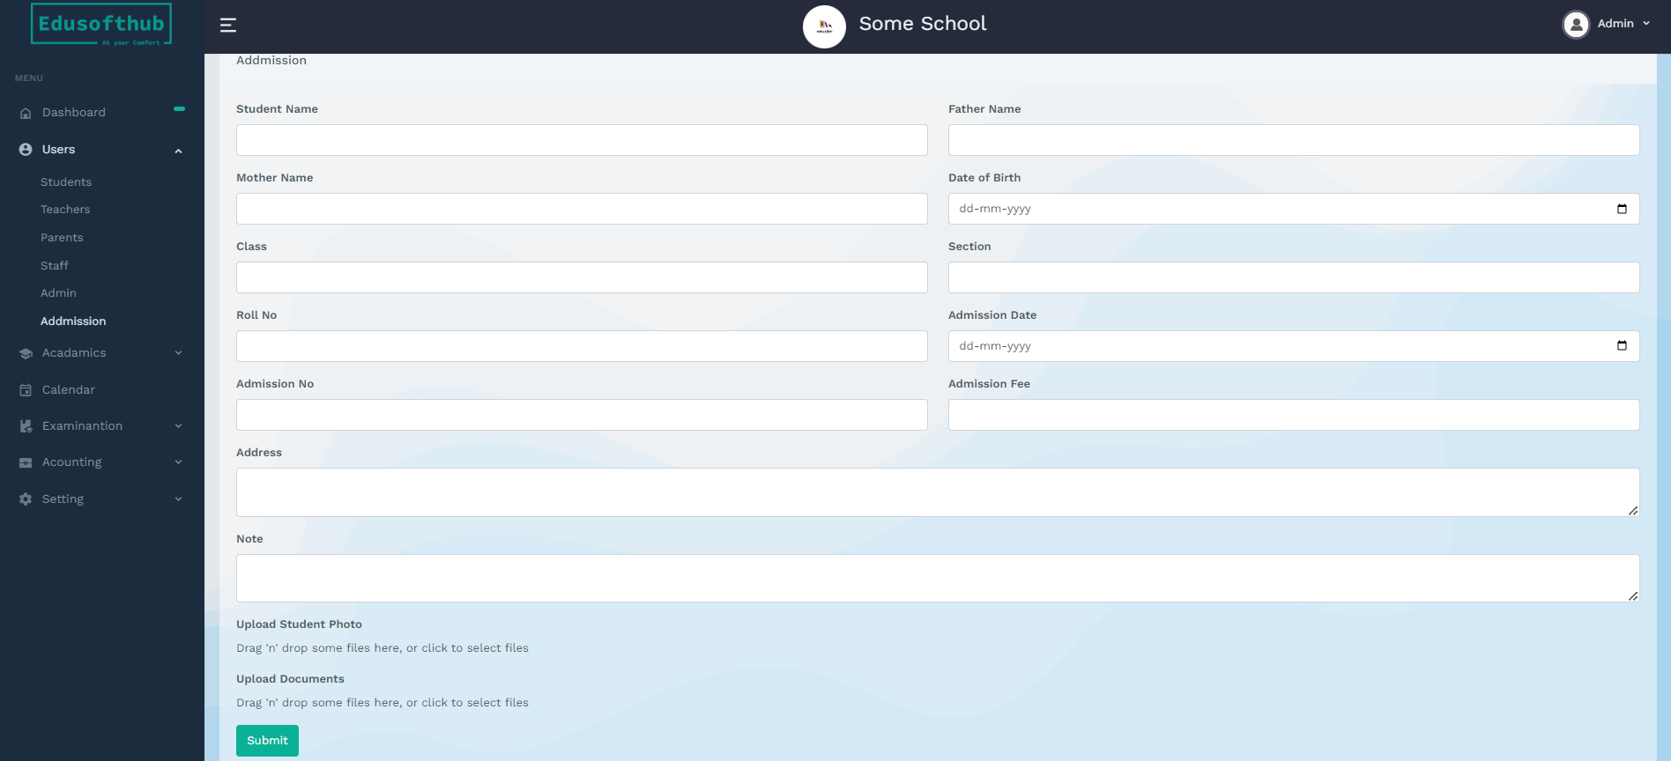

**6.1.20 Admin can take dmission through this portal when click on submit button**

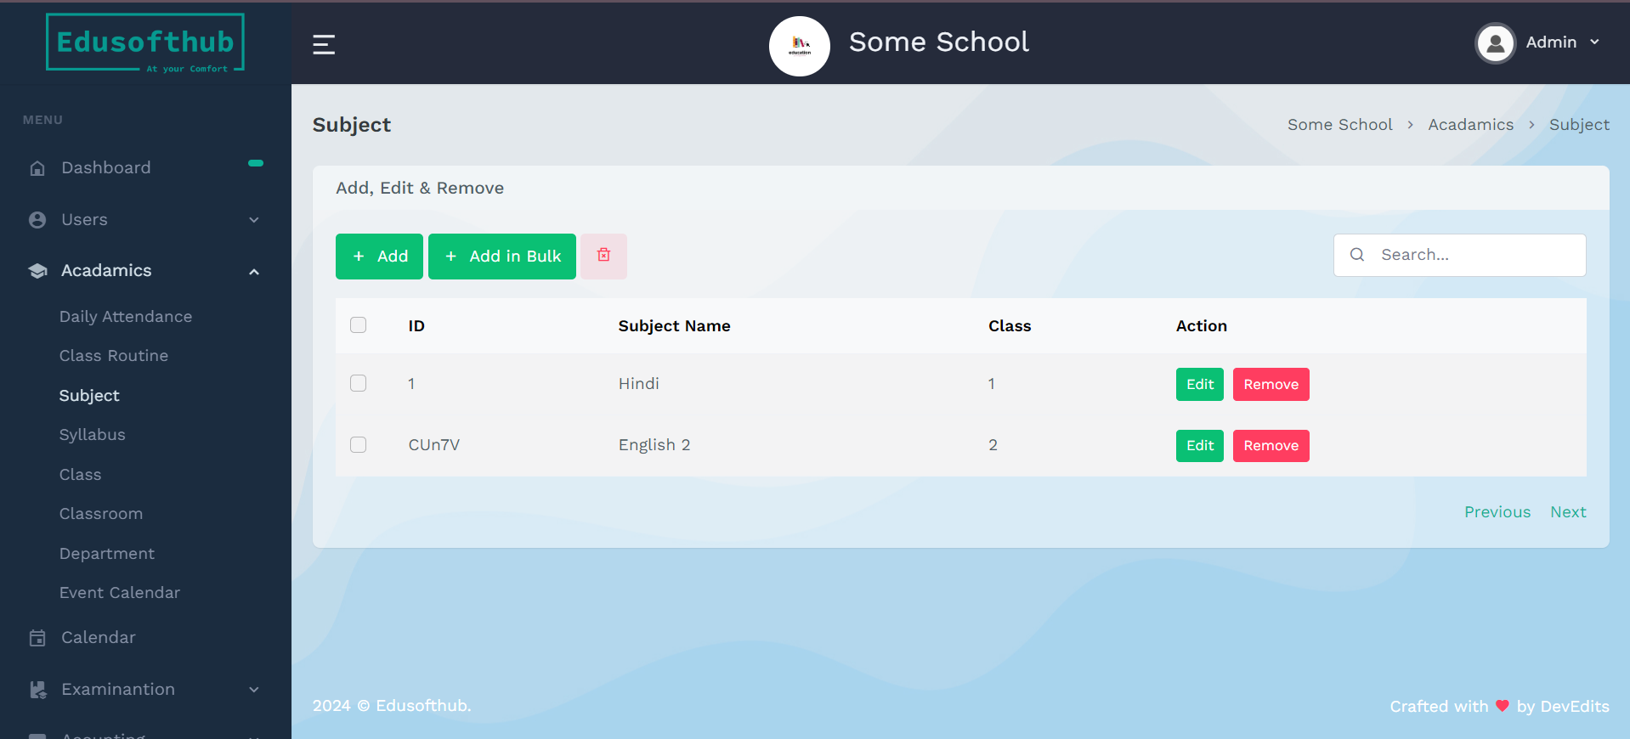

**6.1.21 Admin can add , remove and edit Subject from here**

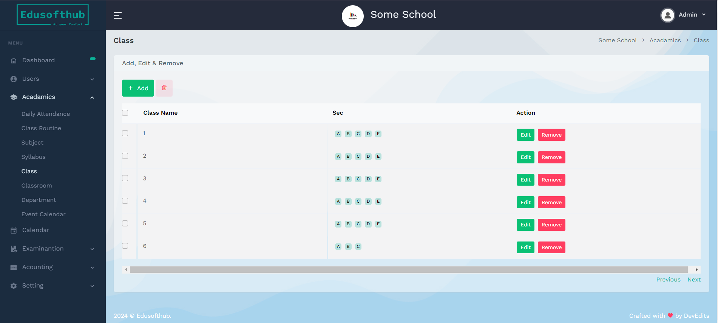

**6.1.22 Admin can add , remove and edit Class from here**

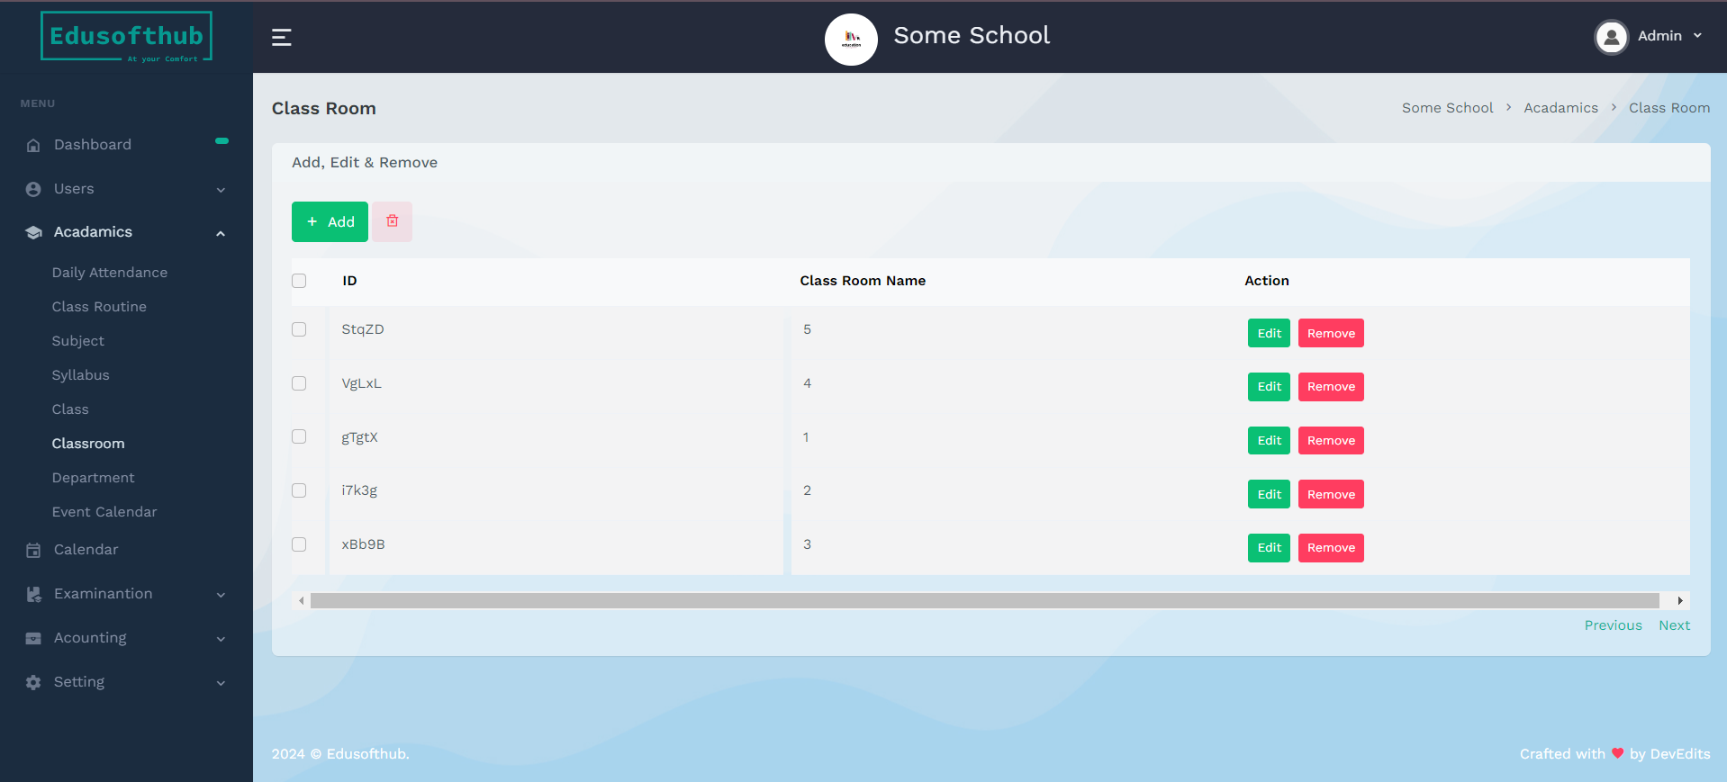

**6.1.23 Admin can add , remove and edit Classroom from here**

**Chapter 7**

**Software Testing**

This process includes the verifying of conclusive stage plan; it is verified to see whether the genuine result meets the normal result. It gives the best possible data to the customers regarding the quality and execution of the product; here application is confirmed and approved to check whether the product is free from errors.

**Various testing levels**

**Unit testing**: - it the basic and important step in the process of testing. Unit testing is something which is done without any doubt. It is testing method which is followed in the complex process of software testing. When the programmer develops application, it should pass unit resting. The project will be divided into number of units, then each individual unit is taken and unit testing is performed on it.it is the process where tester will check whether the particular unit is functioning as per the expectation of the client and the programmer. If not, that unit will be sent for reframing. Until and unless a unit passes this test project will not be preceded for future work.

**Module testing**: - In the application each individual module is tested separately so that its functionality can be checked completely. It plays a major role and helps the tester to test the whether the functionality is as desired in the source code.

**Integration testing**: - it is another variation in the testing process. A project after clearing the unit testing and module testing it enter a level called as integration testing. Here each unit is combined into modules based on the logic of the behavior. Then module is integrated into a single system. Integration testing is testing mechanism which tests the application is working correctly or not when all the modules are integrated as a single unit. Individual units may work correctly but when they are combined into a single unit it may not work as it is intended to work. To find such faults in the application integration testing plays an important role.

**System testing: -** It plays an important role; this test tends check the overall functionality of the system. The complete and overall performance of the application can test using this test. It checks whether the application behaves as specified in requirement phase of the application development.

**Acceptance test: -** After the development of the application and passing all the above-mentioned tests finally before installing it in client’s office without a doubt it should pass mandatory test called Acceptance test. Here the customers will check whether the developed application will help to resolve the problems which he was facing earlier. If the customer did not get satisfied about the product, then it cannot be approved.

**Various Testing Strategies**

**Behavioral Testing -** it i**s** also referred as black box testing since here the behavior of the system is checked. It is one the test which is performed by tester during the development of an software in an organization. Basically, here the testers will not have any idea of code used in the development. Testers will SRS document along with them during the process of testing they will check the functionality of the application is matching the functionalities which given in the SRS document. Here the functionality of the system id checked. Here

Tester’s main focus is on getting correct output for the specified input.

**Open Box Testing-** It is otherwise referred as glass Box Testing, white box testing. It referred as white box testing the reason behind this is, here the tester will complete knowledge of the code which is used to develop the software. It is a kind of software testing technique, here code used for developing the application is known to the tester in prior of performing testing. The analyzer picks commitments to rehearse courses through the coding snippets and choose the correct outcome.

**Dim Box Testing**- it is a strategy to test the product item or application with fractional information on the inside operations of an application. The reason for this testing is to look for mal functionality which is happened because of inappropriate code structure or using the applications functionality in an undesired way

**Test Case**

These are the condition that verifies or contrasts the real outcome and the normal result which decides the product is approved, confirmed and error free. This includes some fields like Test case Id, Description, Actual result, Expected result and Status. Here field names are self-explanatory, status is a field which tell whether the test case is passed or not.

**Test Data**

It is a field in test table. It is the input which is used to check whether the system gives the desired output or not.

**Test Report**

It is supposed to be experiments which contain definite portrayal of tests to be performs and it contains the information of real result from the product or an application which is contrasted and the normal result that outcomes showing a status whether the experiment is pass or not passed.

**Description**

Description tells how to perform the testing that is how to compare the resulted output with the expected output. It is a procedure which makes the testing easier.

**Test Case Header**

Application Name: EduSoftHub

Technique Applied: Decision Table

**Test Case Body**

**Registering / Login in test cases**

|  |  |  |  |  |  |
| --- | --- | --- | --- | --- | --- |
| **Testcase_id** | **Description** | **Procedure** | **Expected**  **output** | **Actual output** | **Status** |
| TC_01 | Admin login | Navigate to login page and give the username and  Password | Displays admin home page | Displayed admin Home page | Pass |
| TC_02 | User registering to the application | Go to the sign up page and enter the details which is asked  in the page | Successfully registered msg should be displayed | displayed Successfully registered msg | Pass |

|  |  |  |  |  |  |
| --- | --- | --- | --- | --- | --- |
| TC_03 | User login | Go to the user login screen and enter the registered user name and  Password | Home page is displayed | Displayed Home page | Pass |
| TC_04 | Login with incorrect details | Go to the login screen and enter user name  and password | Error msg should display | Displayed error msg like invalid username or  password | Pass |

**Test Cases for Operations performed by admin**

|  |  |  |  |  |  |
| --- | --- | --- | --- | --- | --- |
| **Testcase_id** | **Description** | **Procedure** | **Expected output** | **Actual output** | **Status** |
| TC_05 | Create new user | From admin panel click on add user and give the required details | Displays a msg like user added successfully | Displayed a msg like user added successfully | Pass |
| TC_06 | Create new Teacher | From admin panel click on add Teacher and give the  required details | Displays a msg like teacher added successfully | Displayed a msg like teacher added successfully | Pass |
| TC_07 | Modify the details of the existing student | From admin panel click on manage student and give the required details | Displays a msg like student updated successfully | Displays a msg like student updated successfully | Pass |
| TC_08 | Delete the user | From admin panel click on manage user  and then delete | Displays a msg like product deleted  successfully | Displayed a msg like product deleted  successfully | Pass |

**Test case Footer**

Author Name: Dhruv Raj Singh

Date: 30/03/2024

Reviewed By: Ramesh Sir

**Chapter 8**

**Conclusion**

The School Management System project aims to revolutionize the way educational institutions manage their administrative tasks. By providing a centralized platform for all stakeholders, it will enhance communication, efficiency, and transparency within the school ecosystem. This system will not only simplify day-to-day operations but also improve the overall educational experience for students, teachers, and parents alike.

This report outlines the objectives, features, technologies, and implementation plan for the School Management System. With careful planning and execution, we anticipate significant benefits for the school community and a more streamlined approach to school administration.

**Chapter 9**

**Future Enhancement**

These enhancements can improve the efficiency, effectiveness, and overall experience of the School Management System, benefiting students, parents, teachers, and administrators alike. Each enhancement should be carefully evaluated based on the school's specific needs, budget, and priorities.

Attendance Management System: Implement a module to manage student and staff attendance. This can include features such as marking attendance, generating reports, and sending notifications to parents for student absences.

Exam and Result Management: Integrate a system for creating and managing exams, entering exam results, and generating report cards. This can include features for grading, calculating averages, and providing analytics on student performance.

Library Management: Develop a module for library management, allowing students and staff to check out books, view available resources, and manage due dates. This can include features for tracking book inventory and generating reports on library usage.

Financial Management: Implement a system for managing school finances, including fee collection, salary payments, budgeting, and financial reporting. This can provide administrators with better insight into the school's financial health.

Parent-Teacher Communication: Enhance the system to facilitate better communication between parents and teachers. This can include features such as messaging, parent-teacher conference scheduling, and progress reports sent directly to parents.

Online Learning Platform: Develop an online learning platform for delivering digital lessons, assignments, and quizzes. This can be especially useful during times of remote learning or as supplementary material for in-class teaching.

Transport Management: Integrate a module for managing school transportation, including route planning, tracking buses, and notifying parents of bus arrivals and departures. This can improve student safety and efficiency of transportation operations.

Health Records Management: Implement a system to maintain health records of students, including medical history, immunizations, and emergency contacts. This information can be crucial for school nurses and administrators in case of emergencies.

Event Management: Enhance the system to manage school events such as sports days, cultural festivals, and parent-teacher meetings. This can include features for event scheduling, registration, and coordination of resources.

Staff Performance Evaluation: Develop a module for conducting staff performance evaluations, setting goals, and tracking professional development. This can help in improving teaching quality and staff satisfaction.

Mobile Application: Create a mobile app version of the SMS to provide easy access for parents, students, and teachers. The app can include features like notifications, attendance tracking, homework assignments, and exam schedules.

Data Analytics and Reporting: Implement advanced data analytics to provide insights into student performance trends, attendance patterns, and resource utilization. Customizable reports can help administrators make informed decisions.

Integration with Learning Management Systems (LMS): If the school uses a separate LMS, consider integrating it with the SMS for seamless data transfer and a unified experience for students and teachers.

**Bibliography**

**Appendix A**

**Reference Books**

* Software testing and Analysis- Process, Principles and Techniques, by Paul C Jorgensen Software engineering 8th edition by Ian Summerville.
* "School Management Systems: Design and Implementation" by Peter Jones
* https://www.campcodes.com/projects/php/school-management-system-in-php/#School_Management_System_Flowchart

**Reference Websites**

* [www.w3schools.com/](http://www.w3schools.com/)
* https://www.educationworld.com/
* [www.tutorialspoint.com/](http://www.tutorialspoint.com/)
* [www.google.com/](http://www.google.com/)
* https://openai.com/gpt-3/
* https://dev.mysql.com/doc/